POSITIONING THE INFINITY G20

# MARKETING ANALYTICS RENU DEEPYA ISKA | 22-04-2024

## CASE STUDY OVERVIEW

The case study delves into the positioning analysis of the Infiniti G20, an entry-level luxury car marketed by Infiniti in the 1990s and early 2000s. Despite being positioned as a competitor to European luxury sport coupes like the BMW 3-series, the G20 achieved only niche status in the market. Using perceptual mapping software, the study explores how consumers perceive the G20 compared to its competitors, analyzing preference data and market shares to gain insights into consumer behavior and inform marketing strategies. Recommendations are provided to enhance Infiniti's market segmentation and positioning efforts, along with an evaluation of the software's advantages and limitations for such analyses.

The analysis in the case study primarily revolves around utilizing perceptual mapping software to comprehend consumer perceptions regarding the Infiniti G20 and its competitors. By retaining the first three dimensions of the perceptual map, which explain 84.0% of the data variance, the study aims to visualize how consumers perceive various brands in relation to one another.

The analysis involves examining the variance explained by each dimension, interpreting object positions on the map, understanding attribute coordinates, and identifying segment preferences and market shares. Through these analyses, the study aims to uncover trends in consumer preferences, segment characteristics, and market positioning.

## Question 1

### Using the data in Exhibit 1 and the associated perceptual mapping software, describe the two (or, if applicable, three) dimensions underlying the perceptual maps that you generated. Based on these maps, how do people in this market perceive the Infiniti G20 compared with its competitors?

1. Dimensionality Selection:

* Three dimensions were chosen for analysis to provide a comprehensive understanding of the perceptual landscape.
* These dimensions collectively explain 84.0% of the variance, ensuring a robust representation of consumer perceptions.

1. Dimension Interpretation:

* Dimension 1: Reflects attributes related to attractiveness, prestige, and success. Brands positioned positively on this dimension are perceived as more attractive, prestigious, and successful.
* A diagram of a company's financial data

  Description automatically generated with medium confidenceDimension 2: Dominated by attributes such as reliability, comfort, and service. Brands positioned higher on this dimension are perceived as more reliable, comfortable, and offering better service.
* Dimension 3: Represents characteristics like sportiness, value, and uniqueness. Brands positioned positively here are perceived as sportier and offering better value.

1. Infiniti G20 Perception:

* Dimension 1: The G20 appears neutral in terms of attractiveness and prestige, lacking a distinct advantage in these areas.
* Dimension 2: Perceived as moderately reliable, comfortable, and with satisfactory service levels, but not excelling in any aspect.
* Dimension 3: Positioned as an average option in terms of sportiness and value, without a clear differentiation from competitors.

1. Comparison with Competitors:

* The G20's positioning is characterized by a lack of clear advantages compared to competitors.
* It is perceived as a balanced option across dimensions, without any standout features.

1. Implications:

* The chosen dimensions offer a comprehensive view of consumer perceptions, highlighting areas where the G20 can improve its positioning.
* Understanding these perceptions can guide Infiniti in refining its marketing strategies to better meet consumer preferences and differentiate itself from competitors.

## Question 2

### Infiniti promoted the G20 as a Japanese car (basic version $17,500) with a German feel, basically a car that was like the BMW 318i ($20,000), but lower priced. Is this a credible claim, given the perceptions and preferences of the respondents?

Based on the perceptual mapping analysis conducted, we can delve deeper into the positioning of the Infiniti G20 in the luxury car market and assess its alignment with the claimed attributes of being a Japanese car with a German feel, like the BMW 318i but offered at a lower price point.

The perceptual maps provide a comprehensive visual representation of how consumers perceive the G20 in comparison to its competitors within the luxury car segment. Through the analysis of these maps, we can discern the unique positioning of the G20 relative to other brands in terms of various attributes such as performance, design, and pricing. However, it's important to note that while these objective attributes can be compared, the subjective notion of a "German feel" may not be adequately captured solely through quantitative analysis.

To further evaluate the credibility of Infiniti's claim, it is imperative to conduct additional qualitative research methods. Surveys or focus groups aimed at exploring the concept of a "German feel" in luxury cars could provide deeper insights into consumers' perceptions and preferences regarding the G20. This qualitative data would complement the quantitative findings from the perceptual mapping analysis, offering a more holistic understanding of how consumers perceive the G20 relative to its competitors and the extent to which it embodies the claimed attributes.

Further evaluations which include,

1. Market Segmentation Analysis: Infiniti can conduct a segmentation analysis based on the perceptual maps to identify distinct customer segments within the luxury car market. By identifying clusters of consumers with similar preferences and perceptions, Infiniti can tailor its marketing strategies and product offerings to better meet the needs of each segment.
2. Competitive Benchmarking: Comparing the position of the G20 against key competitors on the perceptual maps allows Infiniti to identify areas of strength and weakness relative to other brands. This competitive benchmarking provides insights into opportunities for differentiation and strategic positioning within the market.
3. Brand Image and Reputation: Assessing the perception of the Infiniti brand as a whole, not just the G20 model, provides insights into the overall brand image and reputation. Understanding how consumers perceive the Infiniti brand relative to competitors informs brand-building strategies and marketing initiatives.
4. Price Sensitivity and Value Proposition: Analyzing consumer preferences related to pricing and perceived value helps Infiniti refine its pricing strategy for the G20. Understanding the trade-offs consumers make between price and perceived value informs pricing decisions and enhances the G20's competitive positioning.
5. Longitudinal Analysis: Conducting a longitudinal analysis of perceptual mapping data over time tracks changes in consumer perceptions and preferences. This longitudinal perspective identifies emerging trends, monitors shifts in consumer sentiment, and guides adjustments to marketing strategies.
6. Geographic Variations: Analyzing geographic variations in consumer perceptions uncovers regional preferences and market dynamics. Understanding how perceptions vary across regions informs localized marketing efforts and regional product strategies.

In conclusion, while the perceptual mapping analysis serves as a valuable tool for understanding consumer perceptions and preferences, it is essential to supplement it with qualitative research to assess the validity of Infiniti's claim regarding the G20's resemblance to the BMW 318i with a "German feel." This comprehensive approach will enable a more nuanced evaluation of the G20's positioning in the luxury car market.

## Question 3

### Which attributes are most important in influencing preference for these cars in the segments shown on these maps (Note: Use the Segment preference data option in the positioning dialog box and specify 3 segments) To which segment(s) would you market the Infiniti G20? How would you reposition the Infiniti G20 to best suit the chosen segment(s)? Briefly describe the marketing program you would use to target the chosen segment(s).

1. Brand Preference:

* The G20 holds a strong average preference rating of 7.00, suggesting that it is well-regarded among customers. This high preference may be attributed to several factors, including its perceived attractiveness, sportiness, and reliability.
* Saab, Honda, and BMW also enjoy relatively high average preference ratings, indicating that these brands possess attributes that resonate well with customers. Saab's reputation for prestige and innovation, Honda's emphasis on reliability and performance, and BMW's combination of luxury and driving dynamics likely contribute to their favorable perception.

1. Segment Preferences:

* Segment 1 exhibits a clear preference for brands like G20, Saab, and Honda. Customers in this segment seem to value attributes such as attractiveness, comfort, and reliability. These brands may have built a strong reputation for delivering on these aspects, thereby attracting customers who prioritize them.
* In Segment 2, overall preference levels are lower compared to other segments. Brands like Ford and Pontiac receive relatively lower average preference ratings in this segment. This could suggest that customers in Segment 2 prioritize different attributes, such as affordability and fuel efficiency, over factors like luxury or performance.
* Segment 3 displays a more varied preference pattern, with brands like Audi and Toyota garnering higher average preference ratings. This segment may place emphasis on attributes such as innovation, performance, and reliability. Audi's reputation for cutting-edge technology and Toyota's track record for quality and dependability likely appeal to customers in this segment.

1. Market Shares:

* Analyzing the simulations of market shares across different dimensions reveals the competitive positioning of the G20 in the market.
* In Dimension I-II, where the G20 is favorably positioned, it maintains market shares comparable to other leading brands. This suggests that attributes like sportiness and reliability contribute significantly to its competitiveness in this segment.
* Similarly, in Dimension I-III and Dimension II-III, the G20 competes effectively against other brands, indicating that attributes like attractiveness, comfort, and reliability play a crucial role in influencing market shares.
* 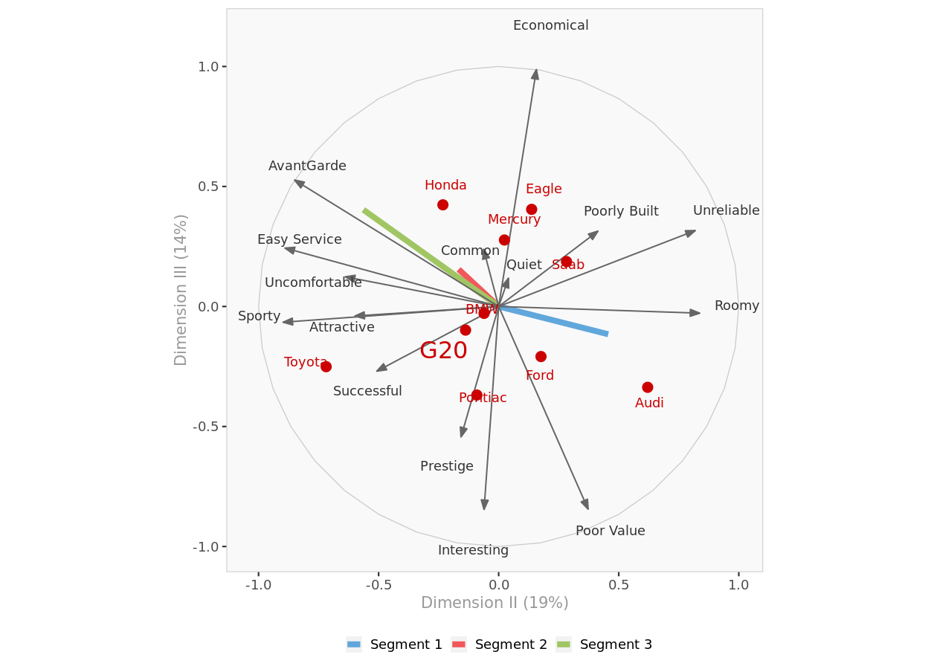The G20's ability to maintain competitive market shares across multiple dimensions underscores its strength in meeting customer preferences and differentiating itself from competitors.

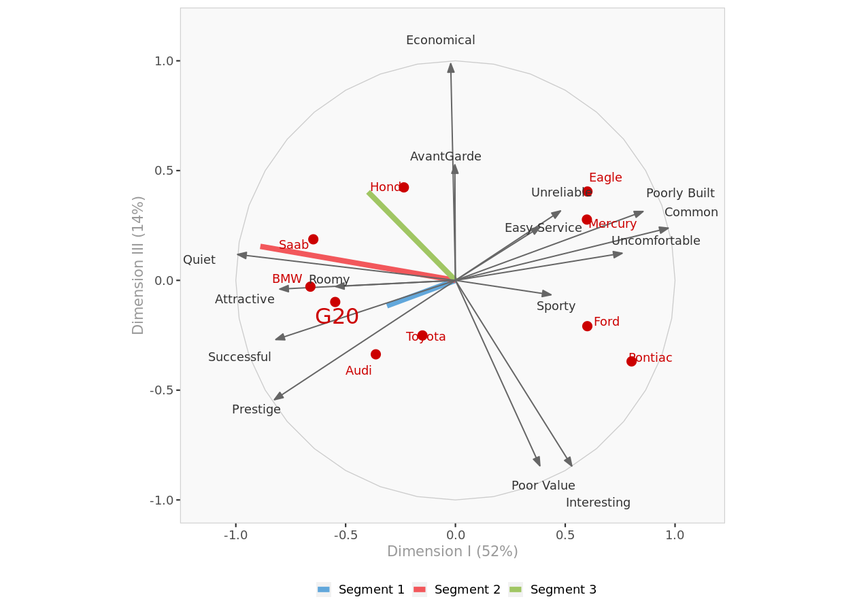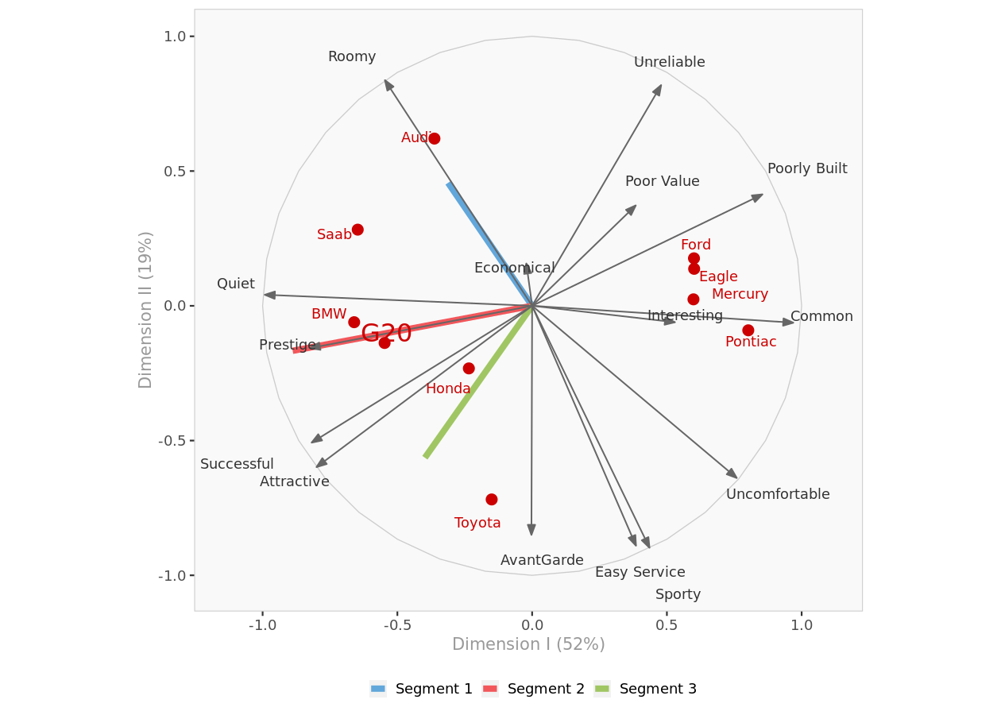

Based on the analysis of brand preferences, segment preferences, and market shares, it appears that Segment 2 might be the most promising target for the G20. This segment shows a higher preference for the G20 compared to other segments, along with a preference for attributes like sportiness and attractiveness, which are strengths of the G20. Therefore, targeting Segment 2 could potentially yield higher market shares and better alignment with the G20's positioning and attributes.

## Question 4

### What ongoing research program would you recommend to Infiniti to improve its evaluation of its segmentation of the market and positioning of its G20?

Recommending ongoing research programs for Infiniti to enhance its evaluation of market segmentation and positioning of the G20:

1. **Customer Surveys and Interviews:** Conduct regular surveys and interviews with current and prospective G20 customers to gather insights into their preferences, needs, and perceptions. Explore topics such as driving preferences, feature priorities, brand perceptions, and purchase decision-making factors.

Example: Conducting surveys to gauge customer satisfaction with current features and identifying desired enhancements. Interviews with potential buyers to understand their considerations when choosing a luxury vehicle like the G20.

1. **Segmentation Analysis:** Continuously analyze market segmentation data to identify emerging trends, shifts in consumer behavior, and new segments of interest. Use advanced analytics techniques to segment the market based on demographics, psychographics, and behavioral characteristics.

Example: Using demographic data to identify segments such as young professionals, urban commuters, or luxury enthusiasts. Analyzing psychographic traits like lifestyle preferences and values to uncover hidden segments.

1. **Competitive Benchmarking:** Conduct regular competitive benchmarking studies to assess how the G20 stacks up against key competitors in terms of product features, pricing, positioning, and brand perception. Identify areas of competitive advantage and areas for improvement.

Example: Comparing pricing strategies, feature offerings, and brand positioning of the G20 against rivals like the BMW 3 Series, Audi A4, and Lexus IS. Assessing customer satisfaction ratings and resale value of competing models.

1. **Brand Tracking Studies:** Implement brand tracking studies to monitor changes in brand awareness, brand perception, and brand loyalty over time. Track key brand metrics among different customer segments to understand how positioning efforts are resonating with target audiences.

Example: Tracking metrics such as brand awareness, brand favorability, and brand loyalty through regular surveys. Analyzing changes in brand perception following marketing campaigns or product launches.

1. **Market Trend Analysis:** Stay abreast of market trends and industry developments related to luxury automotive and entry-level luxury segments. Monitor shifts in consumer preferences, technological advancements, regulatory changes, and competitive landscape dynamics that may impact the G20's positioning.

Example: Monitoring trends such as the rise of electric vehicles, increasing demand for luxury SUVs, or growing interest in connected car technologies. Adapting product strategies to align with emerging trends, such as integrating advanced driver assistance systems.

1. **Digital Analytics:** Leverage digital analytics tools to track online consumer behavior, engagement metrics, and sentiment analysis related to the G20. Monitor social media conversations, online reviews, and website interactions to gain real-time insights into customer sentiment and preferences.

Example: Analyzing website traffic patterns to identify popular features or content pages related to the G20. Monitoring social media sentiment and engagement metrics to gauge brand sentiment and identify potential influencers.

1. **Product Testing and Feedback:** Continuously gather feedback from customers through product testing sessions, focus groups, and online feedback mechanisms. Solicit input on new features, design elements, and performance enhancements to ensure that future iterations of the G20 meet customer expectations.

Example: Organizing focus groups to gather feedback on prototype designs or new feature concepts for the G20. Conducting usability testing to identify pain points and areas for improvement in the user interface of in-car technology systems.

1. **Longitudinal Studies:** Implement longitudinal studies to track changes in customer attitudes, behaviors, and preferences over time. Follow cohorts of G20 owners and prospects to understand their evolving needs and preferences throughout the ownership lifecycle.

Example: Following a cohort of G20 owners over several years to understand how their perceptions of the vehicle evolve with ownership. Tracking changes in brand loyalty and purchase intentions through regular surveys at different stages of the ownership lifecycle.

1. **Cross-functional Collaboration:** Foster collaboration between marketing, product development, sales, and customer service teams to ensure alignment on research objectives and insights. Share findings across departments to inform strategic decision-making and enhance the overall customer experience.

Example: Establishing regular meetings between marketing, product development, sales, and customer service teams to share research findings and align on strategic priorities. Collaborating on initiatives such as refining messaging based on customer feedback or developing new product features to address emerging market trends.

By implementing an ongoing research program encompassing these methodologies, Infiniti can gain deeper insights into market segmentation dynamics, refine its positioning strategy for the G20, and drive continuous improvement in product development and marketing efforts.

## Question 5

### Summarize the advantages and limitations of the software provided for this application.

The software provided for this application, Perceptual Map, offers several advantages:

1. **Visual Representation:** Perceptual Map provides clear and intuitive visual representations of complex data, such as 2D and 3D perceptual maps, making it easier to understand customer perceptions and market dynamics at a glance.
2. **Dimensional Analysis:** Perceptual Map enables dimensional analysis, allowing users to identify and interpret the underlying dimensions driving customer perceptions. This helps in uncovering key insights into product attributes and competitive positioning.
3. **Segmentation Analysis:** Perceptual Map facilitates segmentation analysis, helping users identify distinct customer segments based on their preferences and perceptions. This segmentation capability allows for targeted marketing strategies and personalized product offerings.
4. **Preference Mapping:** Perceptual Map includes preference mapping features, allowing users to map customer preferences onto the perceptual space. This helps in visualizing the relative attractiveness of different product attributes and brands to customers.
5. **Market Simulation:** Perceptual Map offers market simulation tools for estimating market shares based on customer preferences and positioning strategies. This enables users to evaluate the potential impact of different marketing initiatives on market performance.

However, Perceptual Map also has some limitations:

1. **Data Input Requirements:** Perceptual Map requires input data in a specific format, which may require preprocessing and cleaning before analysis. Ensuring data accuracy and consistency can be time-consuming and may require domain expertise.
2. **Interpretation Complexity:** While Perceptual Map provides valuable visualizations, interpreting the results requires a solid understanding of market research methodologies and statistical analysis techniques. Users with limited expertise may find it challenging to derive actionable insights from the data.
3. **Cost:** Perceptual Map may have associated costs, including licensing fees and training expenses. For organizations with limited budgets, the cost of acquiring and maintaining the software may be prohibitive.
4. **Technical Support:** Users may encounter technical issues or require assistance with software implementation and usage. Prompt and reliable technical support is essential to address any issues and ensure smooth operation of the software.
5. **Learning Curve:** Learning to use Perceptual Map effectively may require time and training, particularly for users who are not familiar with market research software or analytical tools. Investing in training and support can help users fully leverage the capabilities of the software.

In summary, Perceptual Map offers powerful visualization and analysis tools for market segmentation and positioning analysis. While it provides valuable insights, users should be aware of its limitations and invest in proper training and support to maximize its utility.